SRM Annual Meeting 2021
Guidelines and Tips for Virtual Posters, Recorded Technical Presentations, and Field Observations
Like past SRM Annual Meetings, the 2021 meeting will be filled with scientific talks and posters to inform attendees of the newest information on rangeland ecology and management. However, in the virtual meeting, talks will become videos (i.e., *.mp4 files) and posters will become images (i.e., *.pdf files). Video talks and posters will be grouped into 16 different session-themes like Invasive Species, Measuring & Monitoring Ecosystems, Ecosystem Restoration, and Rangeland Fire. Attendees will enter a topic session, view titles, read abstracts, click on video talks or posters, and be able to text questions or set up video chats with authors.
During the meeting, authors will be asked to be logged in and be ready to answer questions at a specified time (10:30 am – 12:15 pm MST; 1 hour & 45 minutes) on either Monday, Tuesday or Wednesday. Authors will not need to sit in a virtual room waiting for questions during this time. Once logged into the meeting, as an author, you can be viewing information anywhere in the meeting, you just need to be available to receive a text message (via the meeting platform) to answer a question or strike up a conversation with people viewing your talk or poster. The text messages are provided by the meeting platform and authors and attendees will not need a separate app or program. Video talks and posters will be available for viewing throughout the meeting and participants will be able to revisit the meeting and view talks or posters for years into the future.
TIPS FOR PRE-RECORDED VIDEO PRESENTATIONS – This year video presentations will take the place of in-person technical and scientific talks that usually occur in concurrent sessions.
- Record an 8 to 10-Minute Presentation – We will post your presentation in a virtual session with other talks on a similar theme. Attendees will click on your talk to view.
- Tips to Keep in Mind – Here’s a few things to keep in mind while creating your recording:
- Content is key – Don’t let your main points get lost in all the gizmos and flashy widgets you can put in a video presentation. Focus on the information you want to convey.
- It doesn’t need to be perfect – Add a human element to your presentation and don’t worry if it isn’t a super-polished, Oscar-worthy movie. Keep to the time limits. Practicing before the “final” recording is still a good idea!
- Engage your audience – Active engagement is difficult in a video, but your work will appear more “real” if you show your face in the video and give a little information about yourself like where you work or how you got started in this line of research.
- Sound and lighting matter – We highly recommend you include a video of yourself talking in at least a part of your presentation. To look your best pay attention to sound and lighting. Make sure there is good light in front of you, such as natural light from a window. Avoid light behind you or your face will be in shadows. Use a headset microphone, lavalier, or the microphone or earbuds from your cell phone to make sure your voice is clear.
- A reminder that if you are including photos taken by others, that you give photo credits.
- A few tips and guidelines for making appealing video presentations are outlined in the document below.

- Record Your Presentation and Save as an *.mp4 File. There are a variety of programs that can be used to make a simple video file. You can use whatever format you like and add elements that you think will engage viewers and make your point. Here are a few ideas to consider:
- Voice-Over PowerPoint Recording – Most people know how to use PowerPoint, it is easy to record a narration over the slides, and you can add a view of yourself while narrating.
  - Example of a simple narrated PowerPoint presentation.
  - A few tips on how to narrate a PowerPoint presentation and export as an *.mp4 file.
  - Instructions on how to record a presentation provided by the Canadian Weed Science Society for their 2020 virtual conference.
- Using Zoom to Record Your Presentation – Zoom is a program that many people know how to use for video conferencing. With just a few clicks, zoom can also be used to record a presentation which includes a view of the narrator.
  - Step by step instructions on how to record a presentation with zoom.
- Dynamic Video Using a Webcam Overlay – Several software programs can integrate slides, your webcam, and movies with lots of interactive options for a professional presentation.
  - Example of a lively presentation with transitions and overlays.
  - Tips to make a dynamic presentation with YouCam.
  - A link to YouCam software by Cyberlink even offering a free version.
GUIDELINES FOR POSTERS – Online posters are similar to those created for an in-person conference.
- Poster with large font and graphics as you would for a physical poster you can print and use later or post in the halls of your institution or in your lab.
  - Make a poster landscape-orientation, 36” tall by 46” wide (recommended) for viewers to zoom in to see details
  - A reminder that if you are including photos taken by others, that you give photo credits.
  - You can make a visually appealing poster in Microsoft PowerPoint by changing the dimensions (Select Design -> Slide Size -> Custom Size) or searching online for a template.
  - Print the document as a 1-page file in Adobe (*.pdf) to be shared and viewed online.
  - Here are a few good examples of *.pdf posters: Example 1 | Example 2
- Alternative formats are boundless if you want to be creative and use an alternative way to communicate information such as:
  - Prezi (Free version available for students & educators | Example & Tips for developing)
  - StoryMaps from www.esri.com (Overview | Example)
  - Or, a web page made with WordPress or Wix or other
SHARING FIELD OBSERVATIONS or FIELD FOCUS – In this virtual meeting we invite members to share their experiences in a video. These will be videos taken in the field as a virtual tour with participants talking and not just a PowerPoint-style presentation. Videos can be taken using a SmartPhone or other video recording equipment. There is free video editing software available to cut pieces out, join clips together, include some transitions between clips, and overlay short pieces of text (e.g., title slide).
- Develop an 8 to 10-minute video and submit as an *.mp4 file.
- OpenShot video editor is a free, relatively easy-to-use software for creating a captivating field video. YouTube Video Tutorial for OpenShot.
- Example of a field tour video.
PRIOR TO SUBMITTING FILES - In order to minimize issues with file uploading or viewing, files should be no larger than 500 MB. Reduce file size to a maximum of 500 MB using various tools:
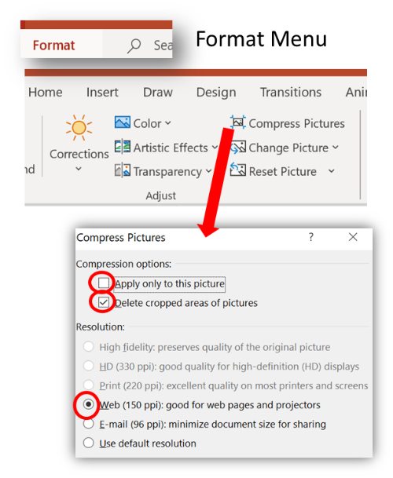
In PowerPoint, file size can be reduced by compressing images:
- Click on an image - any image will do.
- Select “Picture Format”
- Select “Compress Pictures”
- Ensure “Delete cropped areas of pictures” is selected.
- Select the picture quality from the dropdown Web (150 ppt)
- Choose to perform this action on the selected image(s) or all of them.
- Click OK.
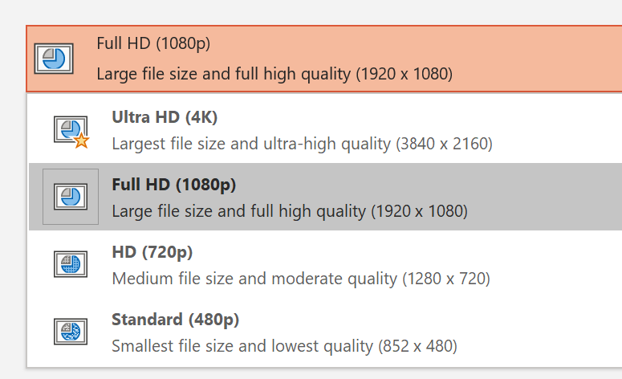
- You can also reduce voice-over recorded presentation file size by Exporting to a video *.MP4. Click File then Export and Create a Video. Select Full HD (1080p) or HD (720p) and the file will be easier to load and look great on a computer screen

- Compress Video files & convert video files to *.mp4 format
- There are many free software programs available, but this is one example: Handbrake and some Instructions on compressing your file

- File name - Name your video file with the following naming convention to assist those who will be uploading your file to our conference platform.
Oxford Abstract submission number_Last name (number, underscore, and letter characters only)
e.g. 311_Smith

SUBMITTING FILES - Upload your *.mp4, *.pdf files.
Please Note: Deadline – Poster and Pre-recorded presentation files are to be submitted by Feb 1, 2021
To Submit your files, upload the files using this form: Submit SRM file form

Questions?
Contact: Lisa Raatz
raatz@ualberta.ca

